

|  |
| --- |
| **Faculty of Applied Sciences and Computing** |
| **Assignment**  **October 2017 Semester** |
| |  |  |  | | --- | --- | --- | | **Course code** | **:** | AACS3064 | | **Course Title** | **:** | Computer Systems Architecture | |
| |  |  |  |  | | --- | --- | --- | --- | | **Students’ Name &**  **ID No.** | **:** | Name: ___________________________ | ID. No.: _______________ | | Name: ___________________________ | ID. No.: _______________ | | Name: ___________________________ | ID. No.: _______________ | | **Programme\*** | **:** | DCO2 / DST2 [**\* Circle whichever is appropriate.]** | | | **Tutorial Group** | **:** | _______________ | | | **Tutor** | **:** | Mr. Wong Hon Yoon / Ms. Choy Lai Fun / Mr. Loh Kian Nyak  [**\* Circle whichever is appropriate.]** | | | **Submission Date** | **:** | **5/1/2018 - Week 12, Friday, before 12 noon** | | |
| |  |  |  |  |  |  |  |  |  | | --- | --- | --- | --- | --- | --- | --- | --- | --- | | **Members’**  **Name** | **Introduction** | **Coding & logic** | | | **I/O design** | **User guide** | **Total** | | | **( 10marks)** | **(25 marks)** | | | | **(5 marks)** | **(40 marks)** | | |  |  |  | | |  |  |  | | |  |  |  | | |  |  |  | | |  |  |  | | |  |  |  | | | **Comment:** | | | | | | | | | **Date of submission** | | | **:** |  | | | | | **Date received**  **(to-be filled by the tutor received)** | | | **:** |  | | | | |

Semester:________________ Course Code & Title: _______________________________

**Declaration**

**I/We confirm that I/we have read and shall comply with all the terms and condition of TAR University College’s plagiarism policy.**

**I/We declare that this assignment is free from all forms of plagiarism and for all intents and purposes is my/our own properly derived work.**

**I/We further confirm that the same work, where appropriate, has been verified by anti-plagiarism software ________________________ *(please insert).***

Signature(s):___________________________________________________________   
[By all members]

Name(s):______________________________________________________________   
[By all members]

Date: ___________________

Table of Contents

**Introduction** **4**

Industry Selected 4

Company Background 4

Functions of the Program 5

Formulas Used 5

Assumptions (Business Rules) 6

Flow Chart 7

**Coding & Logic** **10**

The Power Function 10

Monthly Loan Payment 14

Total Compounded Loan Function 27

**I/O Design** **31**

Logo (No previous action) 31

Login screen (Pressed a key) 31

Login Screen (Pressed ‘Enter’, Incorrect Pass Code) 32

Main Menu (Pressed ‘Enter’, Correct Pass Code) 32

Loan Module Screen 1 - Main (Chose ‘Loan’, pressed ‘Enter’) 33

Loan Module Screen 1 - Prompt Back to Main Menu (Confirm Amount : No) 33

Loan Module Screen 1 - Error (Invalid Character) 34

Loan Module Screen 1 - Error (Input out of range) 34

Loan Module Screen 2 - Main (Confirm Amount : Yes) 35

Loan Module Screen 2 - Retry Enter Year (Confirm Amount : No) 35

Loan Module Screen 2 - Result (Confirm Amount : Yes) 36

Load Module Screen 2 - Continue? (Pressed a key) 36

Loan Module Screen 2 - Result (More Samples) 37

Load Module Screen 2 - Result (More Samples) 37

Loan Module Screen 2 - Result (Min. Result) 38

Loan Module Screen 2 - Result (Max. Result) 38

Receipt Module - Main (No Previous Action) 39

**User Guide** **40**

Software Used 40

Installation 41

Login Password 41

Usage Guidelines 41

**References** **42**

**Appendices** **43**

The Ladder Diagram (Hand Sketch) 43

# Introduction

As the trend of the decade inclines to the importance and development of cloud computing, IoT (Internet of Things), AI (Artificial Intelligence), etc. the focus of this report is however, revolves around a much lower-level of computing - Computer Systems Architecture, which largely consists of deep understanding of computer systems and their architectures, as well as a low-level programming language - the Assembly Language.

The importance of a deep understanding of the computer systems architecture is not to be underestimated, as it sculpts the foundations of the aforementioned trends of computing today.

In this report, a system would be proposed and later, developed, in assembly language, which shall include several arithmetic computation. The system would need to be of a given list of industries, namely:

* Agriculture industry
* Finance services industry
* Community system

## Industry Selected

Hence, given the list of available industries, the one which we opt for is one of the branches of the **Finance Services Industry**, particularly, the **Loan Service Industry**.

While typically loan services are provided by banks, our company of choice is a standalone loan service agency.

## Company Background



***Wolfe’s Loan Corporation*** is a newly registered company that aims to provide legal loan services of many sectors (including vehicle loans, business loans, housing loans, etc. ) to individuals or businesses of any sort.

Being new in the industry, ***Wolfe’s Loan Corporation*** hired IT personnels to develop an 8086 microprocessor based system to measure and calculate several required functions.

## Functions of the Program

The main function of the program being developed would be a loan calculator involving the formulas shown in the next section, which is used to calculate namely:

* Total Compounded Loan
  + Based on a desired amount of loan in USD
  + And the number of year the client wants to borrow the loan for
  + The annual interest rate is set based on the number of year (refer to the Assumptions’ section)
* Monthly Loan Payment
  + The same input parameters as Total Compounded Loan

A receipt will be generated in a text file (receipt.txt), showing all the involved parameters and can be displayed from the ‘Receipt’ module, even after the program is quit.

## Formulas Used<math> <mfrac> <mrow> <mrow> <mtext>LoanAmount</mtext> </mrow> <mo>&times;</mo> <mfrac> <mi>R</mi> <mrow> <mi>N</mi> </mrow> </mfrac> </mrow> <mrow> <mrow> </mrow> <mrow> <mn>1</mn> <mo>-</mo> <mo maxsize="1">(</mo> <mn>1</mn> <mo>+</mo> </mrow> <mfrac> <mi>R</mi> <mrow> <mrow> <mo>N</mo> </mrow> </mrow> </mfrac> <mtext>)</mtext> <msup> <mrow> </mrow> <mrow> <mo>-</mo> <mrow> <mtext>NxT</mtext> </mrow> </mrow> </msup> </mrow> </mfrac> </math>

1. Monthly Loan Payment =

R = Annual Interest Rate

N = Payments per year

T = Number of years

This formula is used to calculate the monthly amortization of a loan, the loan amount is the actual amount borrowed. Based on the formula, the shorter the payment period, the larger the amortization; the longer the payment period, the smaller the monthly payment due.

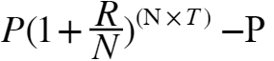

2) Total Compounded Loan =

P = The Total Loan Amount

R = The Annual Interest Rate

N = The Number of Times the Interest is compounded each year(Usually 12)

T = The Number of Years the loan is borrowed for

This formula is used to calculate the Total Compounded Loan the customer pays after completing the consecutive payments for the loan.

## Assumptions (Business Rules)

The business rules define the services offered and the policies of the company in providing the services. The functionalities of a program, like the company itself, must adhere to the business rules set, namely:

* All transactions must be in the currency of USD (US Dollar).
* Minimum loan amount in USD : 1000 (inclusive)  
  Maximum loan amount in USD : 15000 (inclusive)
* Loan amount must be integers only (no decimals). But the results from the calculations will produce decimals rounded off to 2 decimal places.
* Loan durations are specified in years, not months. Clients have choices of 1 to 10 years inclusive.
* Loan Durations and their Interest Rates, respectively:

|  |  |  |  |
| --- | --- | --- | --- |
| **Loan Duration** | 1-3 years | 4-6 years | 7-10 years |
| **Interest Rate** | 30% | 18% | 12% |

* Due to limitations of the 8086 architecture, the accuracy of the results produced by the program would be ≈ ± 1 USD from the actual results.

## 

## 

## Flow Chart

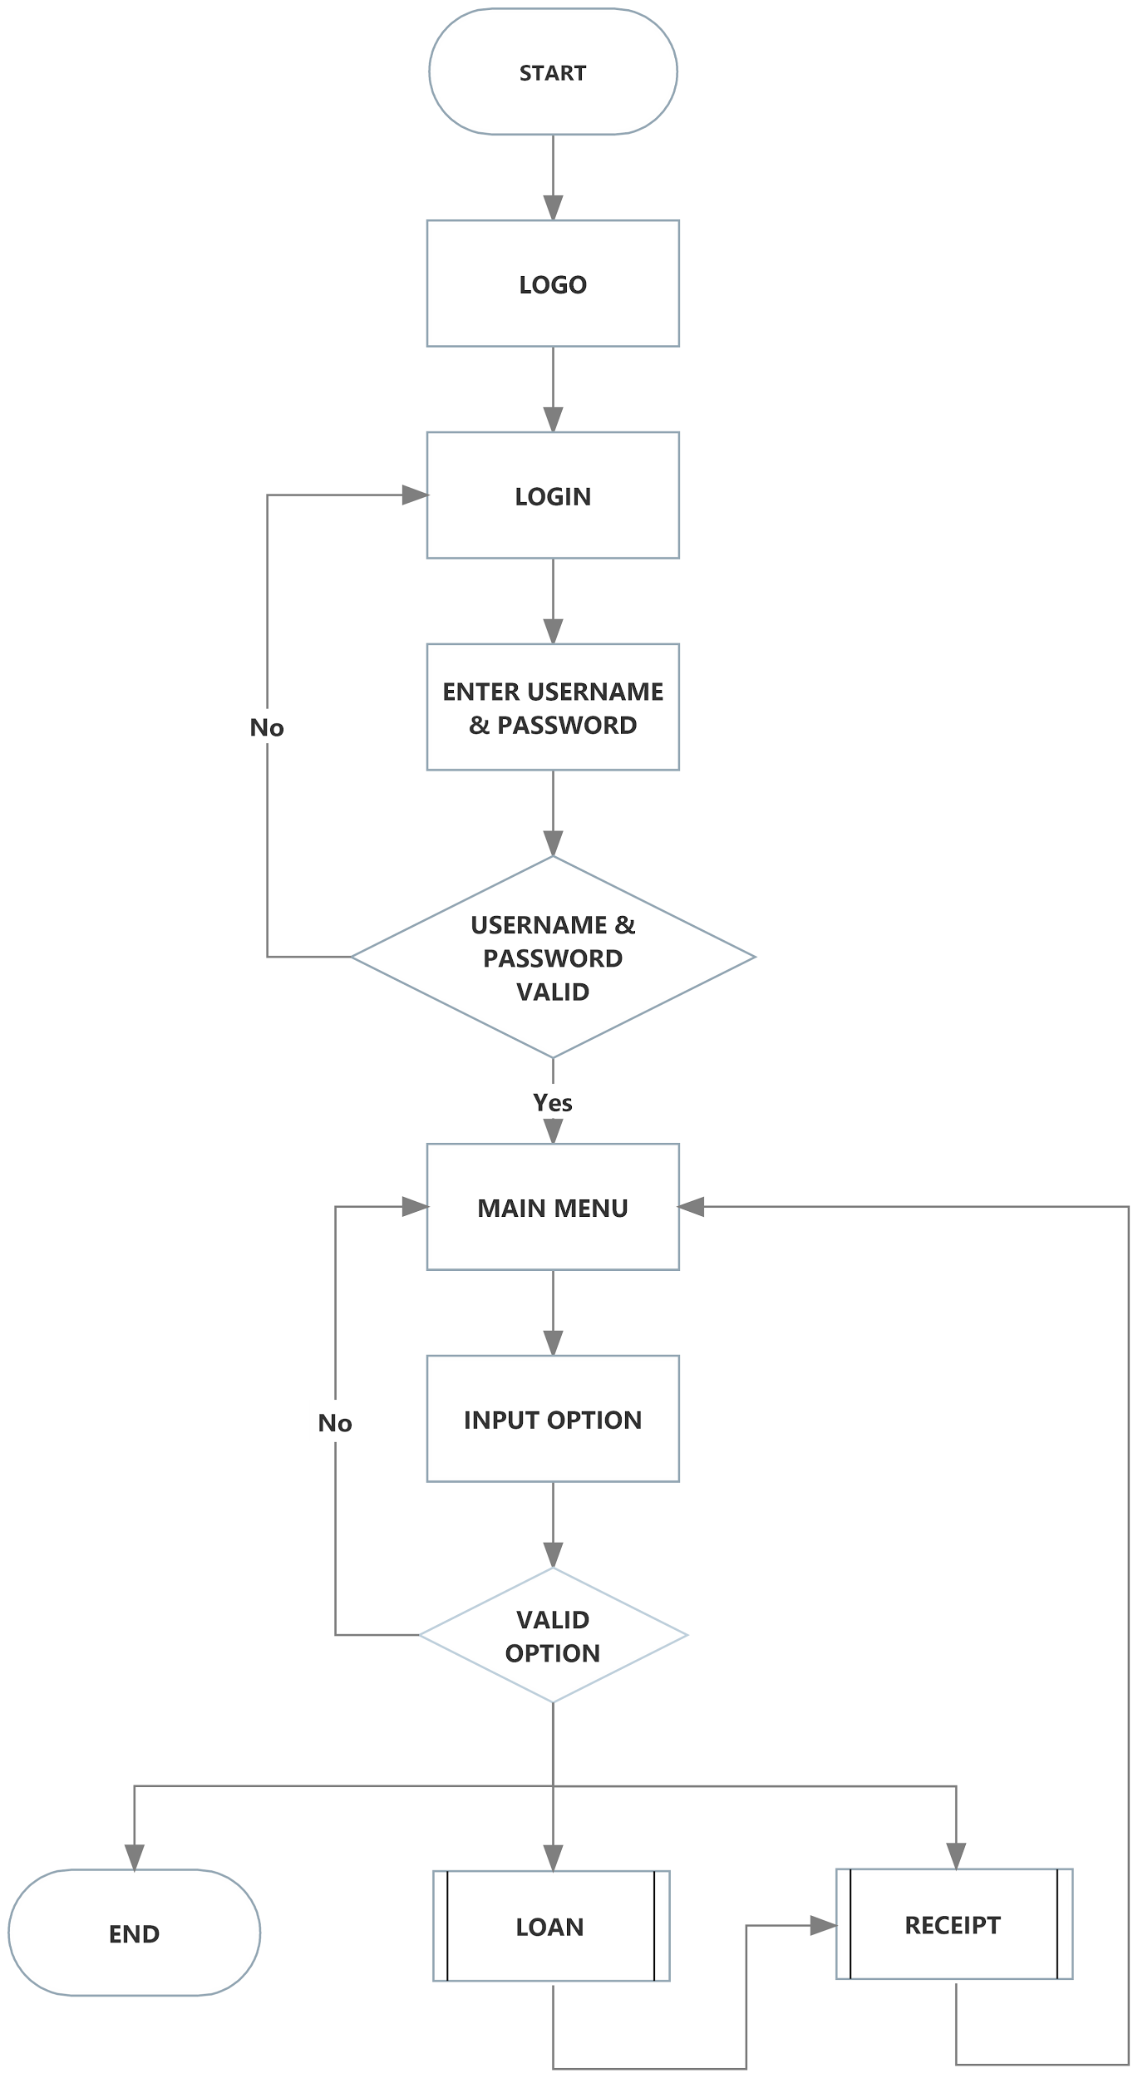

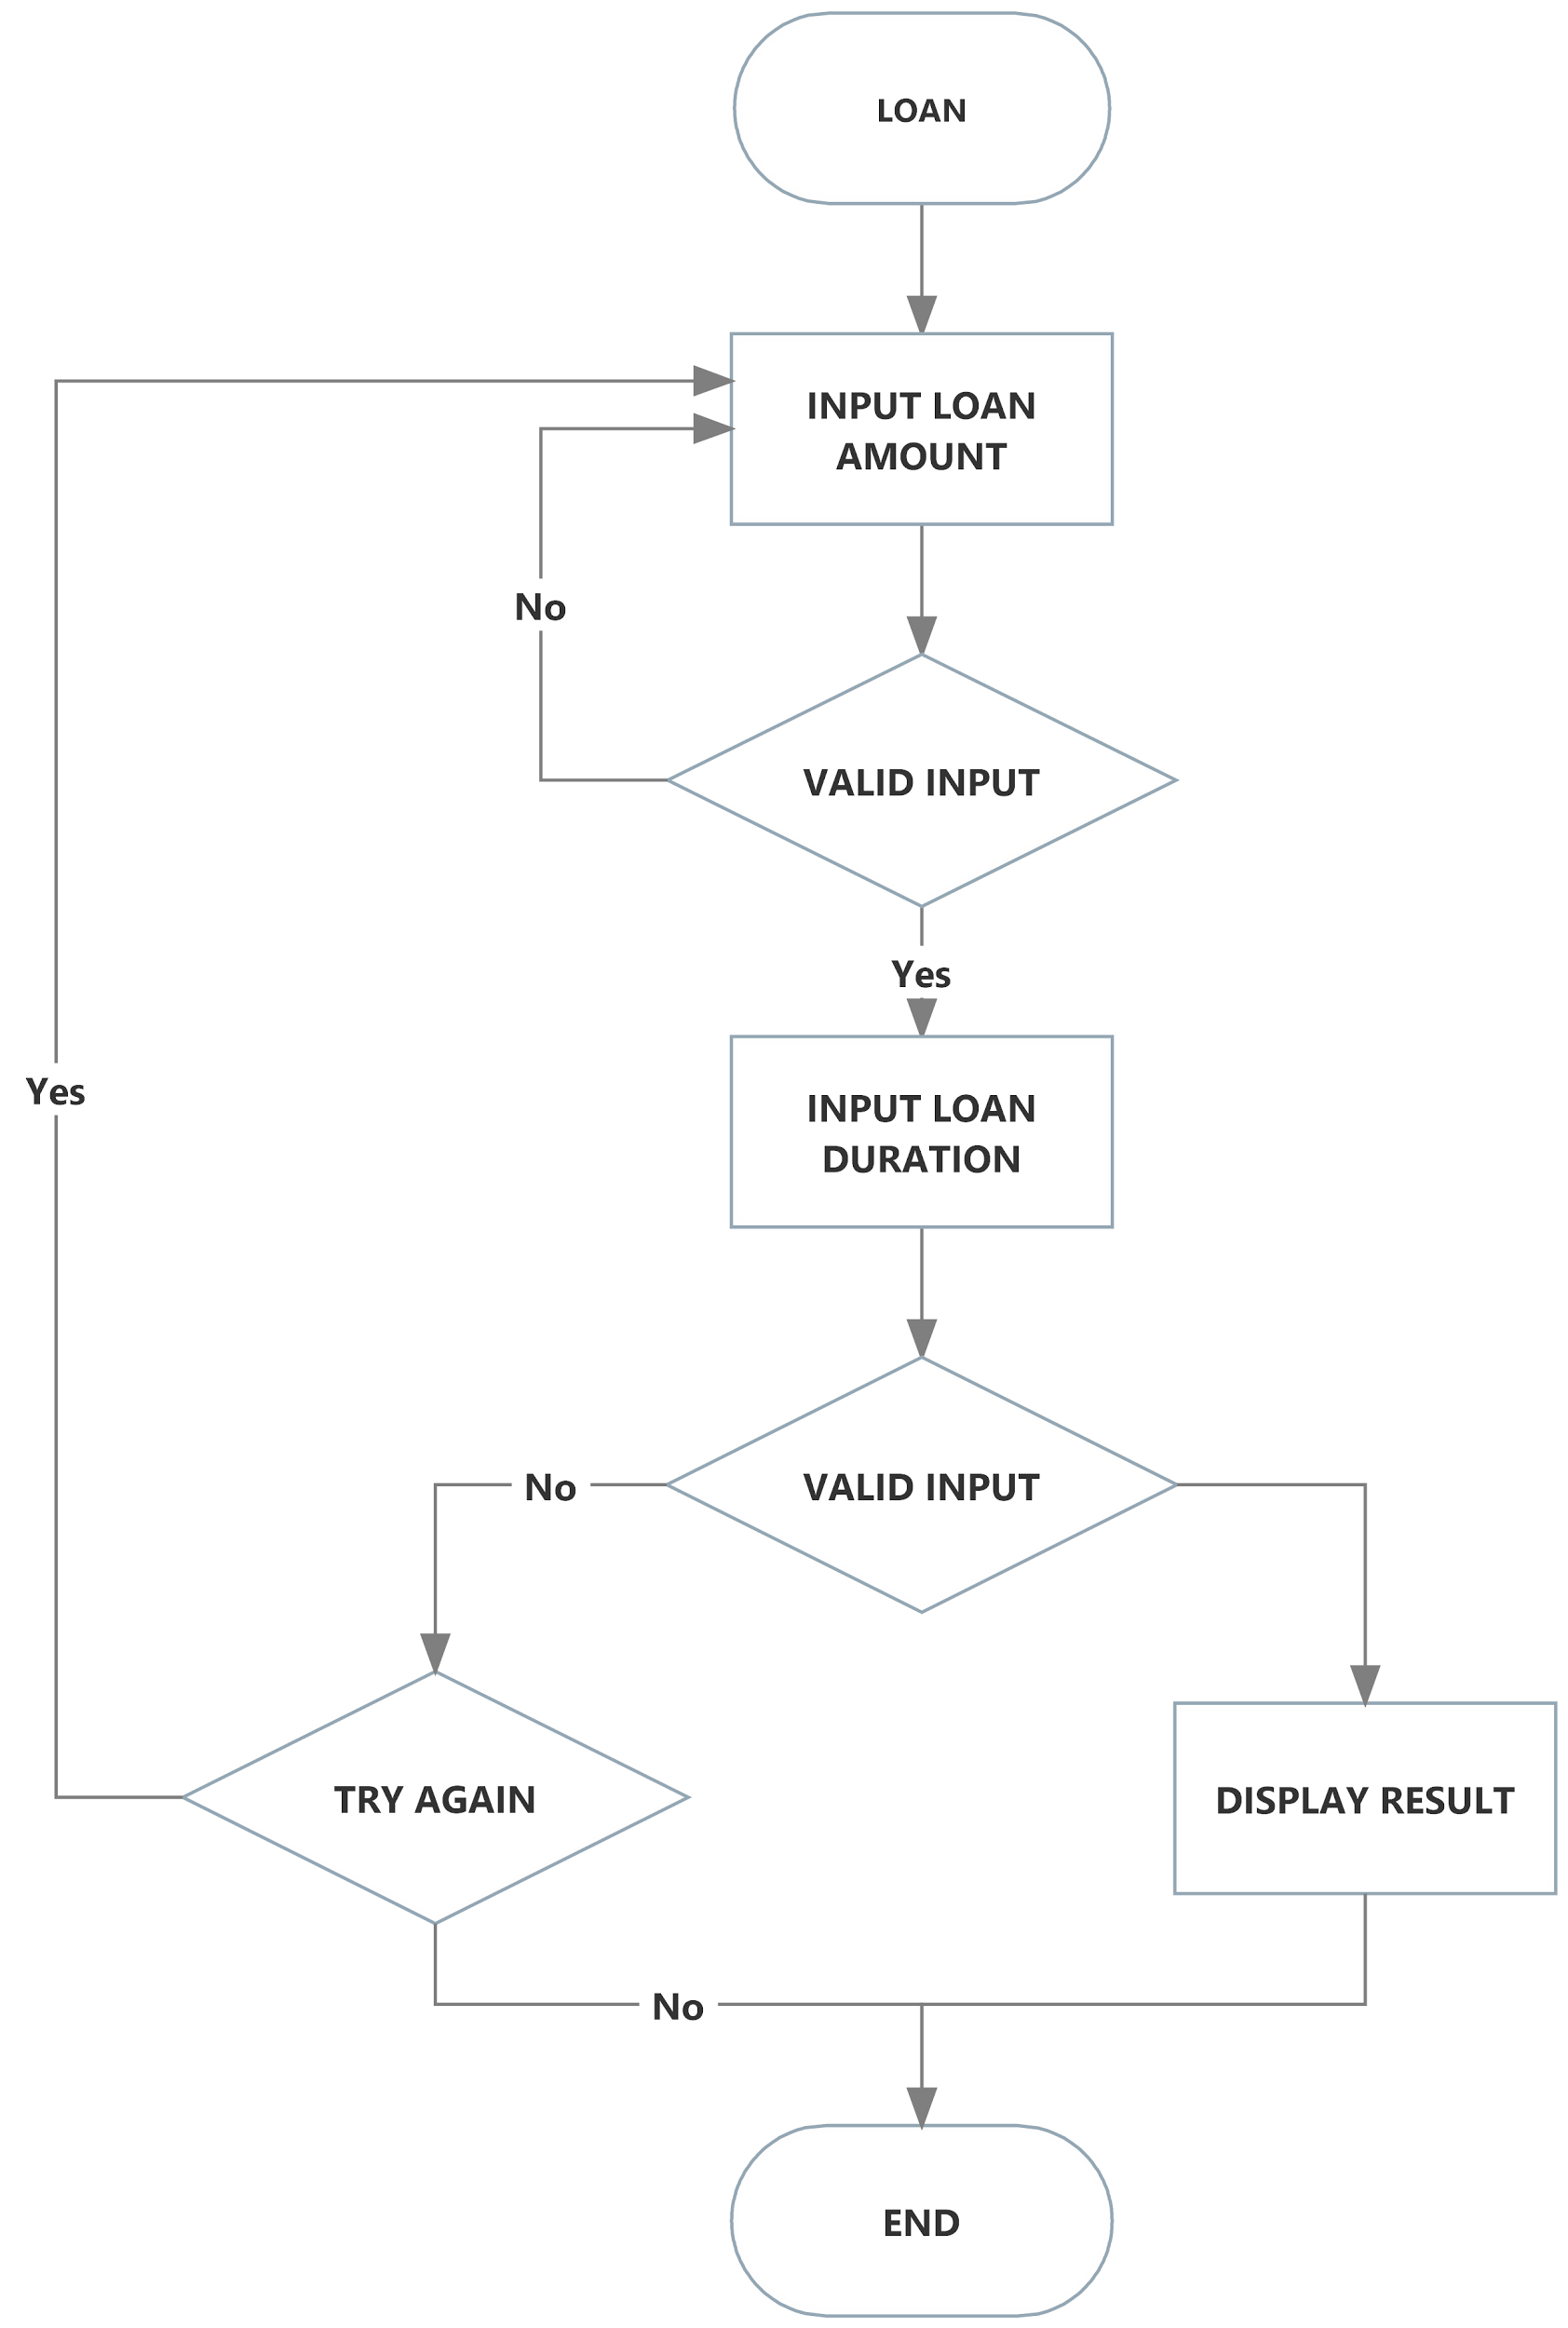

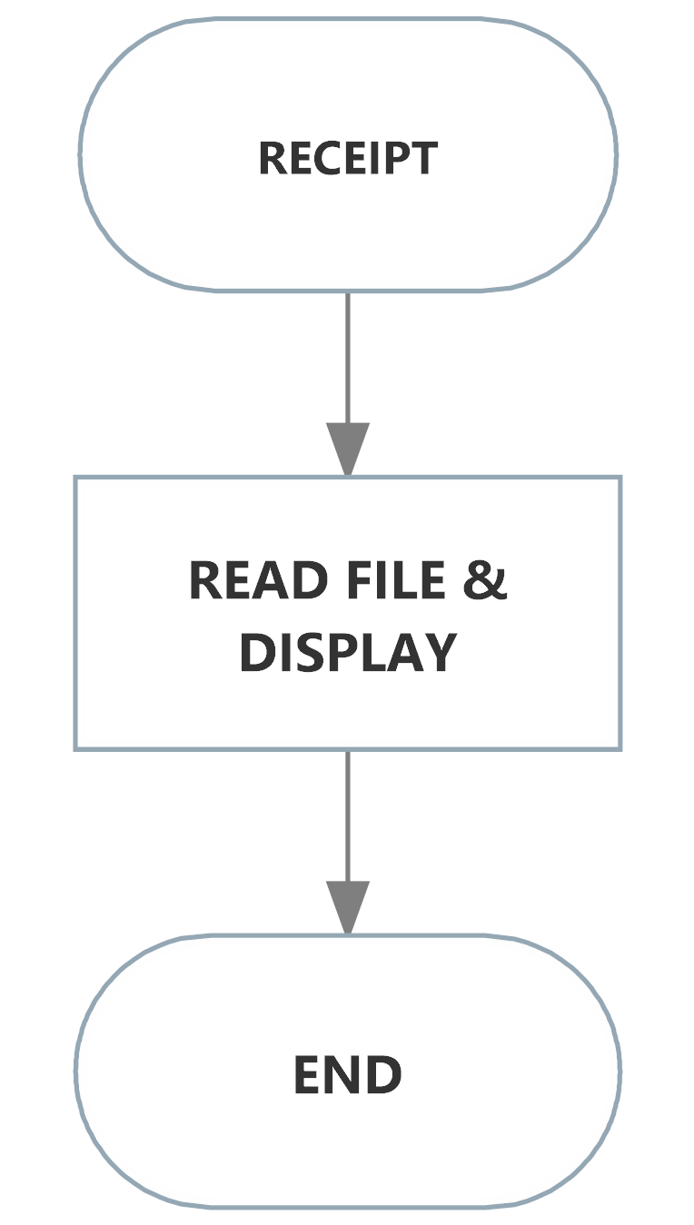

# Coding & Logic

Low-level programming languages like the assembly language only include very basic functions for calculations, hence the calculations for the aforementioned formulas require heavy effort and an abundant amount of logical thinking to be completed.

As such, below are some of the more notable features in the program, along with the detailed explanations of their logic:

## The Power Function

ONG TUN YING

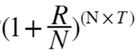

* Calculates power of a floating point number (3 decimal places) up to 4 decimal places and rounds it off to 3 decimal places.
* (1 + R/N) is a constant variable

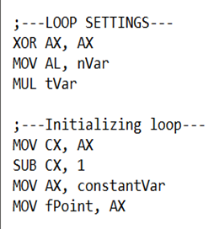

* Set (N x T) by multiplying N, the number of payments per year which is set to default as 12 with T, which is the number of years the loan is borrowed using the AL register.
* Initialize the loop with the result of (N x T) into the CX register and reducing it by 1 because power of 1 is negated.
* Set floating point variable from constant (R/N) selected based on the years borrowed by the user using AX register.

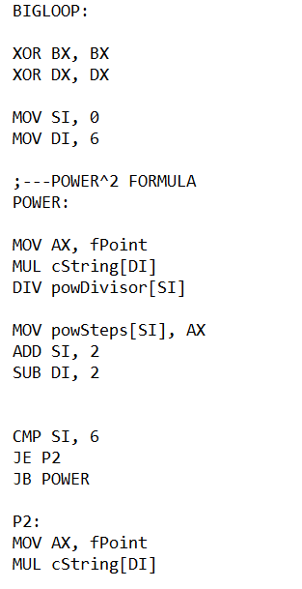

* Set the SI register with 0 and DI register with 6
* The floating point variable contains 4 digits. (E.g. 1.010 = 1010). Multiply the floating point variable starting with the last digit of the constant variable array (e.g. 1.010) using the AX register
* Divide the AX register with powDivisor which contains multiples of 100 starting with 100. The next iteration will be 10, followed by 1.
* Store the result of division into the first position of an array variable called powSteps.
* Add SI register with 2 and subtract DI register with 2. (All variables with array above are WORD sized, 16-bit)
* Compares the SI register with 6, if equal jumps to the next label, P2, if below then jumps back to the power label. (Jumps back approx. 2 times)
* In label P2, the floating point variable is multiplied with the first digit in the constant variable string. Then jumps to label FLOATP

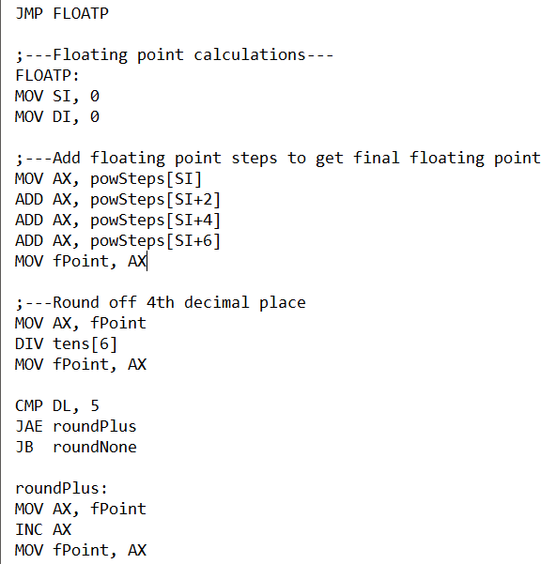

* Label FLOATP adds all the floating points inside the array powSteps into a 4 decimal floating point (5 digit variable now).
* After adding the new values of the floating point, it is moved back into the floating point variable as the new value. This is done using the AX register.
* After that, the new floating point value is rounded off to 3 decimal places.
* This is done by dividing the floating point value by 10 and moving the value back into the floating point variable (4 digit now). After that the DL register is compared with 5.
* If the DL register is equal or above the value 5 it will jump to the label roundPlus and increment the floating point variable by 1 using the AX register.
* However, if the DL register is below 5 it will remain the same value (4 digit, 3 decimal) and jump to label roundNone.

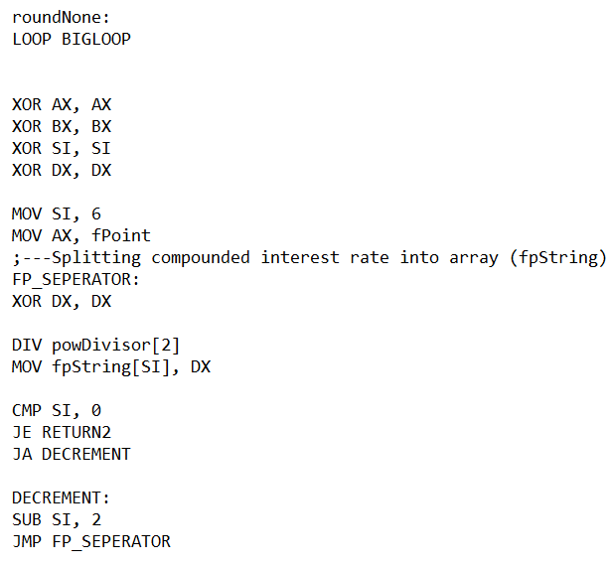

* After that, the label BIGLOOP will be looped and the CX register will decrement by 1.
* After the loop is done executing the SI register is set to 6
* In label FP_SEPERATOR the final value of the floating point variable is split into an array to be used by other functions as a variable.

* The floating point variable is divided by 10 and stored into the final floating point array from the last digit to the first digit by comparing the SI register with 0.

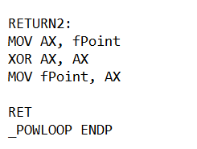

* The floating point variable is cleared using the AX register, then the function returns.

## Monthly Loan Payment

ONG JON SHEN

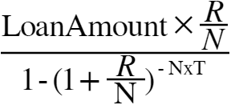

* Calls POWLOOP function to get (1 + R/N)^(N*T) floating point
* Performs division of 2 floating point numbers, 2 decimal places. (Rounded off 3 decimal place to 2 decimal)
* Split into 3 parts of calculation, numerator and denominator, then division of numerator and denominator

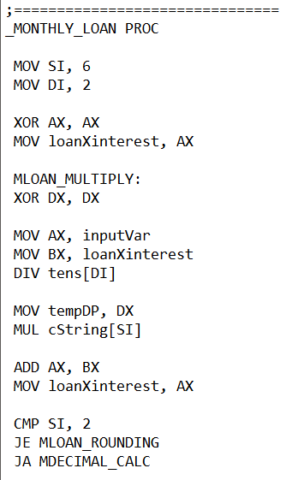

* MLOAN_MULTIPLY calculates the numerator multiplication of the formula.
* The variable loanXinterest is used to store the total value of the numerator after calculation is done.
* loanXinterest is cleared, then the inputVar which contains the loan amount is divided by a 16-bit array variable which contains (10000, 1000, 100, 10, 1). It is first divided by the second place of the array starting at position 2 then lastly at position 8 using the DI register as the offset address.
* The remainder is stored into a temporary Decimal Point holder because the multiplication instruction clears the DX register.
* The AX register is multiplied with the last string constant variable starting from the last decimal place to the second using the SI register as the offset address.
* The result of the AX would be added with the current value of loanXinterest and hence, stored into it.
* The SI register is compared with 2.

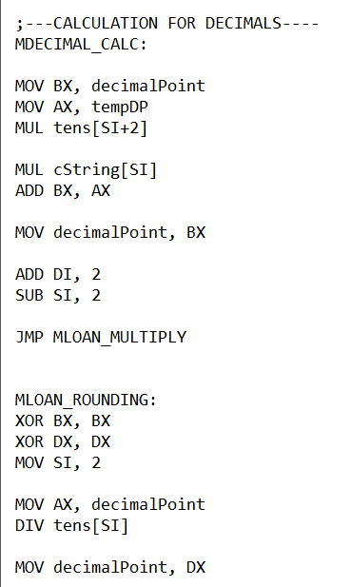

* If the SI register was above 2, it will jump to MDECIMAL_CALC. This calculates the multiplication of the remainder from the division.
* The variable decimalPoint is moved in to the BX register, while the tempDP is multiplied with tens array variable to get up to 3 digits, or 3 decimal places using AX register.
* After that, it is multipled with the constant string variable starting from the last place to the second place using the SI register as the offset address.
* The current value of the decimalPoint variable is added with the result and store into the decimalPoint variable using BX register
* DI register is added with 2 while the SI register is subtract with 2.
* The pointer returns to the MLOAN_MULTIPLY label.
* If the SI register is equal to 2 then it jumps to the MLOAN_ROUNDING label which rounds off any extra decimals and handles the carry.
* If there is any carry after adding up all the decimals together, the 1000th digit of the deicmalPoint var is divided and the remainder of the 3 digits is stored back into the decimalPoint var using the DX register.

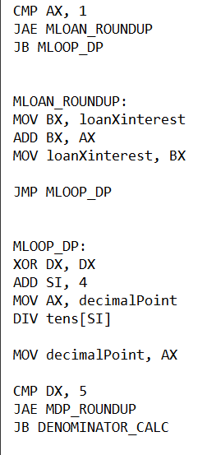

* The carry digit is compared with 1 and if equal or above will jump to MLOAN_ROUNDUP which adds the carry back into the whole number loanXinterest using BX and AX register. It then continues to the MLOOP_DP label.
* Else if the carry digit is zero it will continue to MLOOP_DP label which rounds off the third digit of the decimal point into 2 decimal points.
* The MLOOP_DP label divides the last digit of the decimalPoint with 10.
* The result will be stored back into the decimalPoint var through the AX register. (2 digits now)
* The remainder rounded by comparing with 5, if it is above or equal to the value 5 using the DX register, it will proceed to MDP_ROUDUP which adds one to the 2 digit decimalPoint
* Else, if the remainder is below 5, it will move on to the DENOMINATOR_CALC which calculates the denominator portion of the formula. The value of the decimalPoint is kept at 2 digits.

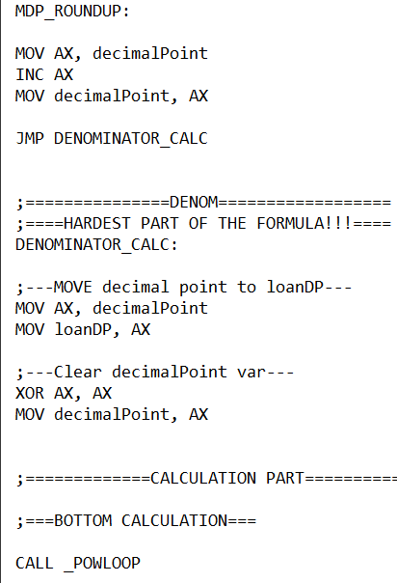

* In MDP_ROUNDUP, the decimalPoint is incremented by 1 using the AX register. Then the new value is stored back into decimalPoint.
* After that, it jumps to DENOMINATOR_CALC for the next part of the formula.
* In DENOMINATOR_CALC, the decimalPoint variable is moved into the loanDP (AX register) variable which will be the decimal point value of the numerator.
* The value of decimalPoint is cleared using the AX register for future use.
* In the CALCULATION PART, the function POWLOOP is called to get the value of (1 + R/N) ^ (T x N). This value is stored inside a string array called fpString.

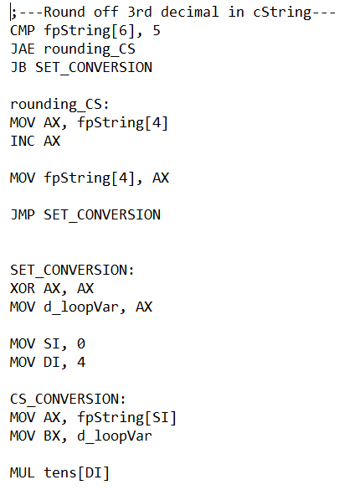

* The 3rd decimal of the constant array string is rounded off for division purposes by comparing the last digit with 5, if the value is above or equal it will increment the second last digit of the string by 1 (AX register).
* Else if the value is below it jump to SET_CONVERSION, which will move the new rounded off value of fpString into a variable called d_loopVar.
* In SET_CONVERSION, each value of the fpString array starting from the second last place will be multiplied with its respective decimal value. (E.g. 1,2,3,4 = 1000 + 200 + 30 + 4).
* This is done by using the SI and DI register as the offset address of fpString and tens.
* After that, CS_CONVERSION will add the new value of the fpString digit into d_loopVar. Using AX and BX registers.

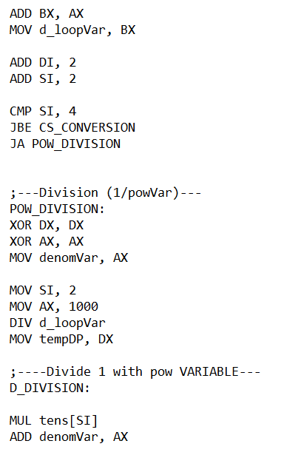

* The DI and SI registers are added by 2, then the SI register is compared with 4. If the value is above it will jump to POW_DIVISION.
* Else it will jump back to CS_CONVERSION at the top.
* POW_DIVISION handles the calculation of (1 + R/ N) ^ (- T x N) which becomes (1 / d_loopVar)
* A new variable is moved into the AX register to store the value of the denominator in whole number.
* By dividing 1000 with d_loopVar we willl get the first digit.
* The remainder will be moved into the tempDP using the DX register.
* After that, the D_DIVISION label will multiply the result with its new respective decimal values of (100, 10, 1) using the variable tens with the offset of the SI register.

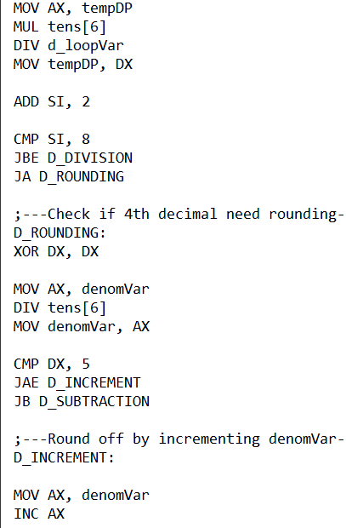

* Then, the result will be added into the denomVar.
* Afterwards, the tempDP is multiplied with 10 (Make it 4 digit long) and divided with d_loopVar. (Using AX register)
* The remainder is stored back into the tempDP
* The SI registers are added by 2
* Set the condition to check if the division is taken place till the offset register SI is above 8. Else it will jump back to D_DIVISION to repeat the whole division process.
* After that, it will jump to D_ROUNDING. This label will check if the 4th decimal requires rounding up.
* The last digit of denomVar is separated by dividing it by 10.
* The new value of denomVar is stored back into it using AX register. (3 decimal now)
* The last digit is compared with 5, if above or equal will jump to D_INCREMENT else will jump to D_SUBTRACTION
* In D_INCREMENT, the denomVar is incremented by 1 and moved back into the denomVar. Then jumps to numerator_division.

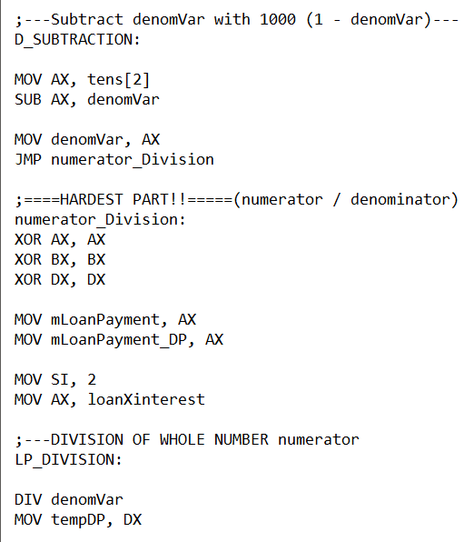

* In D_SUBTRACTION, the formula (1 - denomVar) will take place.
* 1000 is subtracted from denomVar (Contains 3 digits) to get a final value of 3 decimal places. (Using AX register)
* Then the result is moved back into denomVar and it jumps to numerator_Division.
* numerator_Division handles the calculation of the (numerator / denominator).
* New variables are introduced, mLoanPayment (Stores monthly loan payment whole number) and mLoanPayment_DP (Stores monthly loan payment decimal points)
* Move loanXinterest (numerator result whole number)
* LP_DIVISION handles the division of the whole number numerator (loanXinterest)
* Divide loanXinterest with denomVar (AX register)
* Move the remainder into tempDP(DX register)

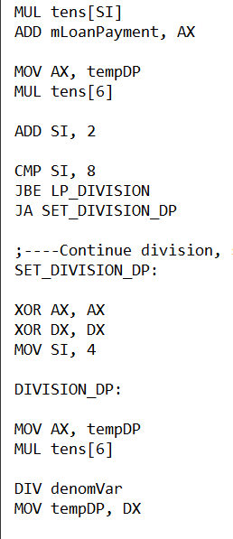

* Multiply with the respective decimal value (1000, 100, 10, 1)
* Add the result into mLoanPayment.
* Multiply back the remainder(tempDP) with 10 in the AX register
* Compare the SI register with 8 to get the complete division of the whole number.
* If SI is above 8 then jump to SET_DIVISION_DP
* SET_DIVISION_DP handles the division of the decimals from the loanXinterest whole number.
* Multiply the reaminder(tempDP) with 10 and divide it with denomVar. (AX register)
* Store ramainder into tempDP (DX register)

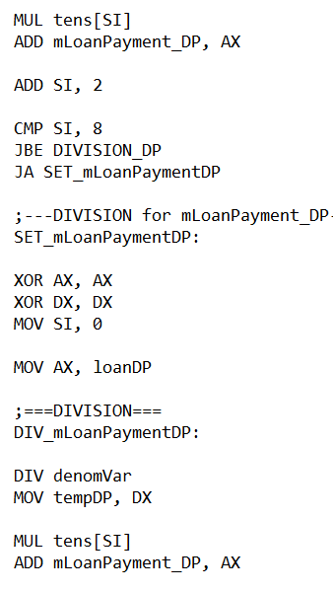

* Multiply the result with the respective decimal places (100, 10, 10) AX register
* Check condition if SI register is below or equal to 8, if true then jump to DIVISION_DP above.
* If false then jump to SET_mLoanPaymentDP
* SET_mLoanPaymentDP calculates the division for the decimal place of loanDP (numerator 2 decimal point)
* Move the loanDP inside the AX register for arithmetic usage.
* DIV_mLoanPaymentDP, handles division process.
* Divide the AX register with with denomVar.
* Store remainder in tempDP
* Multiply the AX register with respective decimals (10000, 1000, 100, 10, 1) If the result of division is zero then then multiplication will also be zero,
* Add the result of AX into DIV_mLoanPaymentDP

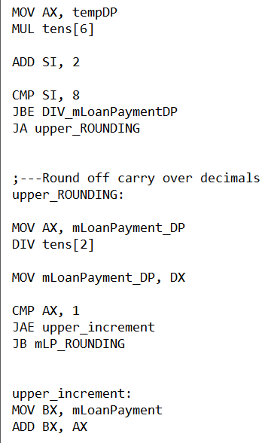

* Multiply the remainder(tempDP) with 10
* Check condition if SI register is below or equal to 8, if true then jump to DIV_mLoanPaymentDP above.
* If above 8 then jump to upper_ROUDNING
* upper_ROUNDING rounds off the carry over decimals into the whole number.
* Divide the 1000th digit of the decimal point mLoanPayment_DP (e.g. 1234, 1 is the carry over)
* Move back the value of the remainder into mLoanPayment_DP
* Compare AX, 1
* If above or equal jump to upper_incremnt
* If below then continue to mLP_ROUDNING
* Add the carry decimal from AX to mLoanPayment through BX.

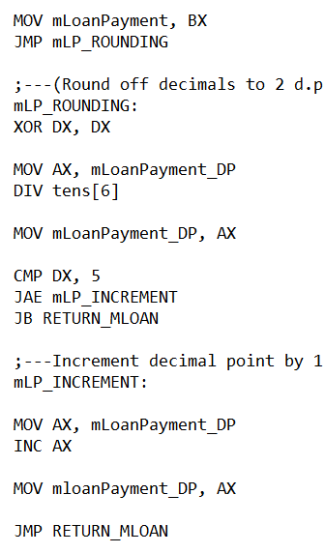

* Store back the new value of mLoanPayment. (Whole number)
* mLP_ROUNDING roundes of the decimals to 2 decimal places (Currently has 3 dp)
* Get the last digit of the decimal point by dividing 10. (AX register)
* Move back the new value of mLoanPayment_DP using AX register. (2 dp now)
* Compare the remainder with 5 (DX register)
* If above or equal, jump to mLP_INCREMENT
* Else if below, jump of RETURN_MLOAN
* mLP_INCREMENT increments the new value of mLoanPayment_DP by 1 (Using AX register)
* Store the new value back to mLoanPayment_DP and jump to RETURN_MLOAN

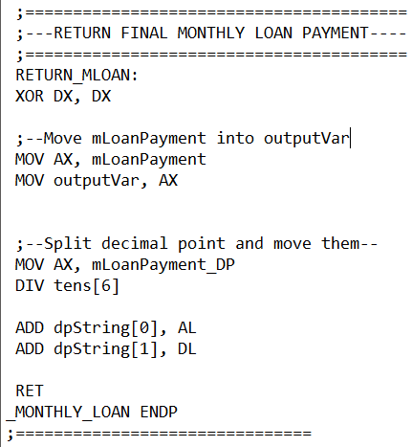

* RETURN_MLOAN moves back the result into the outputVar and splits the decimal points into an array for output later.
* Return function

## Total Compounded Loan Function

OOI KWOK QUEN



* Multiply a 5 digit variable with floating point (3 decimal places)
* (1 + R / N) ^ (N x T) is already set by the POWLOOP function
* P is the Loan Amount

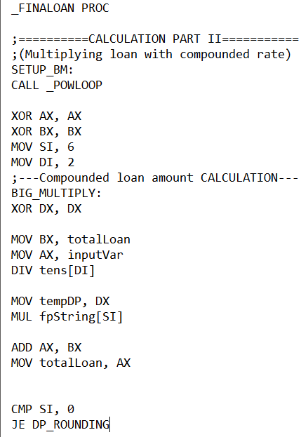

* CALL _POWLOOP to get the value of (1 + R/N) ^ (T x N)
* BIG_MULTIPLY divides the inputVar with tens array from (1000, 100, 10, 1)
* Move the remainder in a temporary variable called tempDP
* Multiply the AX register with the string array of the power variable (Starting from the last digit to the first using SI register as offset address)
* Add the AX with the totalLoan (BX)
* Store the value into totalLoan (AX)
* Compare SI register with 0.

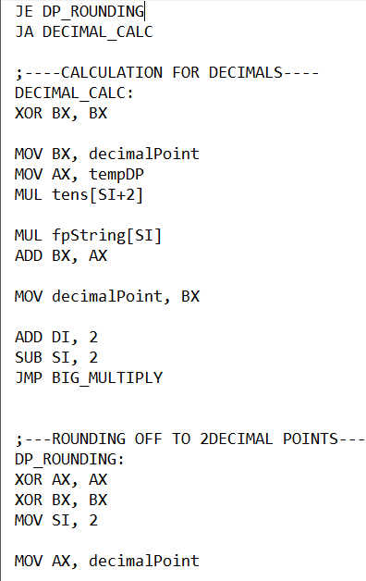

* If equal to 0, jump to DP_ROUNDING
* If above 0, jump to DECIMAL_CALC
* DECIMAL_CALC, does the calculation for all the decimals.
* Multiply the tempDP to get 3 digits
* Multiply the result with the fpString array starting with the last digit (SI register as offset address)
* Add the AX register into the decimalPoint variable
* Store the new value of decimalPoint (BX)
* ADD DI with 2, and subtract SI with 2 to change the offset address the the array varaibles. (16 - bit)
* Jump to BIG_MULTIPLY label
* DP_ROUNDING, Round off the 3 decimal points into 2 decimal points.
* Move in current value of decimalPoint (AX)

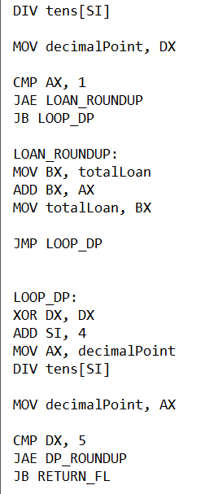

* (Handle carry over)Divide the AX register with 1000 to get the carry over decimal (SI)
* Store the remainder into decimalPoint (3 digit now)
* Compare the AX register with 1, if above or equal then jump to LOAN_ROUNDUP
* Else if below then jump to LOOP_DP
* LOOP_ROUNDUP - Adds the carry over to the whole number totalLoan (AX, BX)
* Store the new value of totalLoan (BX)
* Jump to LOOP_DP
* LOOP_DP - Round off the 3rd digit/ decimal into 2 digits / decimal places.
* Divide decimalPoint with 10 to get the last digit value.
* Move back the new value of decimalPoint (AX, now has 2 digit)
* Compare the remainder with 5, if more than or equal jump to DP_ROUNDUP (DX)
* Else if below jump to RETURN_FL

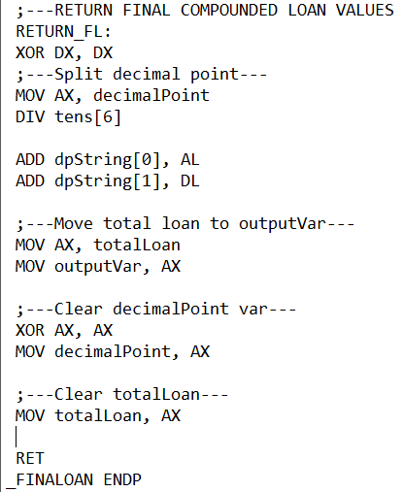

* RETURN_FL - Returns final compounded loan values and clears non-constant variables for reusability.
* Split the decimal points by dividing decimalPoint with 10 and store the answer into an output array called dpString.
* Move totalLoan to the outputVar for output printing.

# 

* Clear variables such as decimalPoint and totalLoan.
* Return function

# 

# 

# 

# I/O Design

The I/O designs of the program shall be presented via print screen outputs:

### Logo (No previous action)

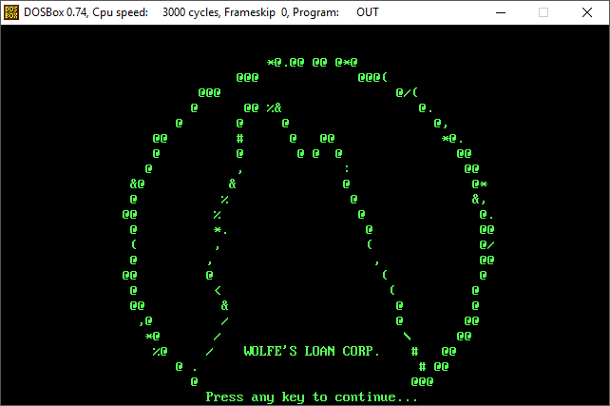

### Login screen (Pressed a key)

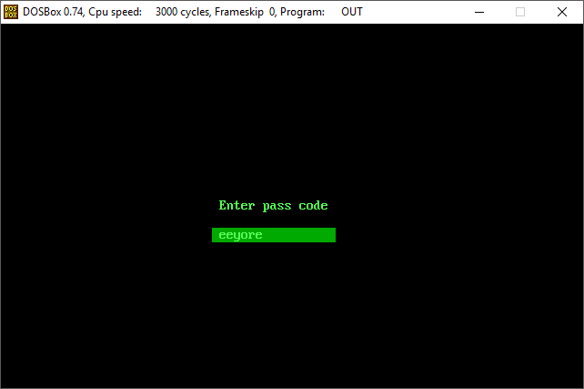  
Pass code : eeyore

### Login Screen (Pressed ‘Enter’, Incorrect Pass Code)

### 

### Main Menu (Pressed ‘Enter’, Correct Pass Code)

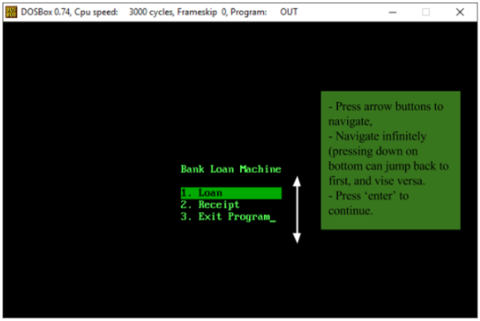

### Loan Module Screen 1 - Main (Chose ‘Loan’, pressed ‘Enter’)

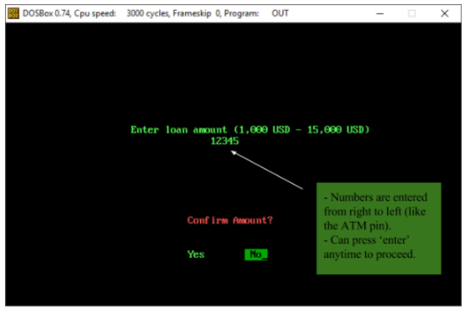  
Sample Data for Loan Amount : 12345

### Loan Module Screen 1 - Prompt Back to Main Menu (Confirm Amount : No)

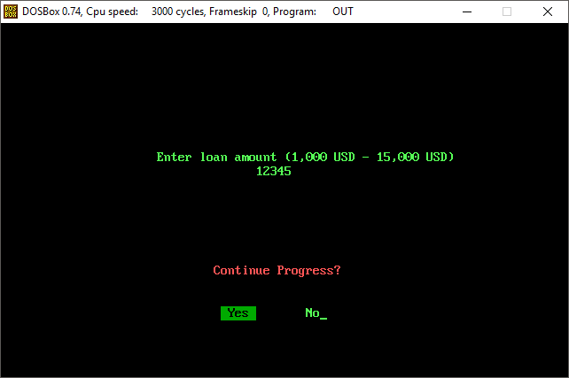  
Continue Progress : Yes (Loop Back to Loan Module Screen 1, Loan Amount resetted)

### Loan Module Screen 1 - Error (Invalid Character)

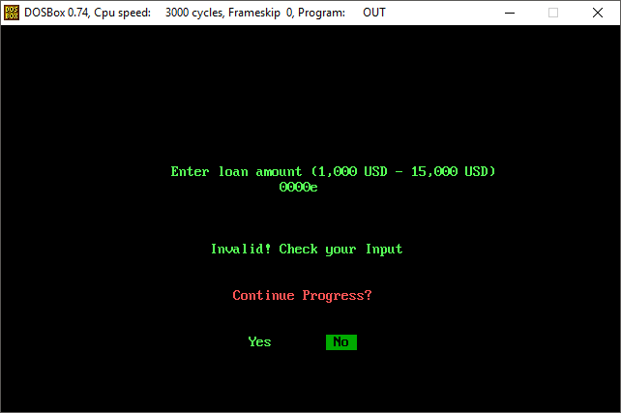

### Loan Module Screen 1 - Error (Input out of range)

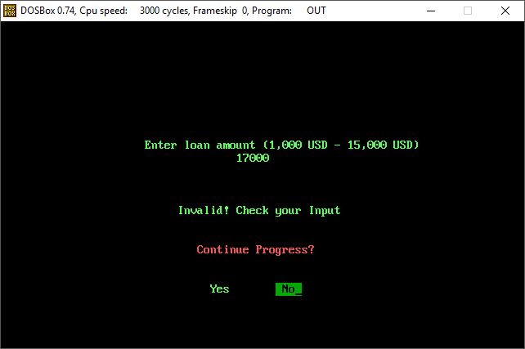

### Loan Module Screen 2 - Main (Confirm Amount : Yes)

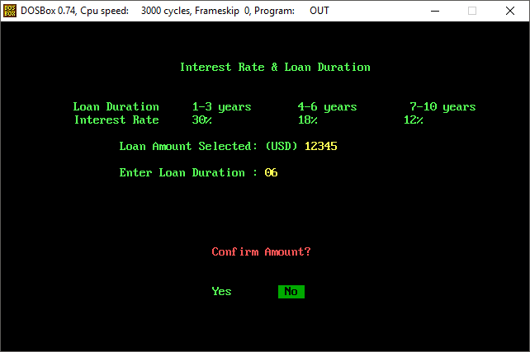  
Sample Data for Loan Duration : 06

### Loan Module Screen 2 - Retry Enter Year (Confirm Amount : No)

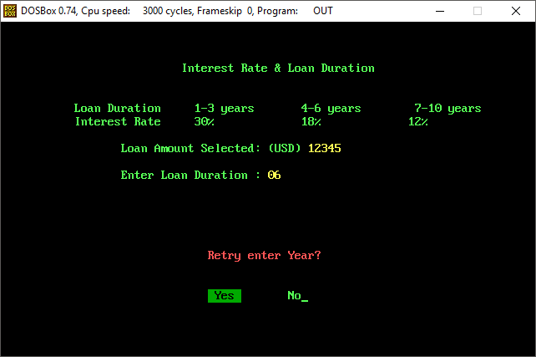  
Retry enter Year : Yes (Loop Back to Loan Module Screen 2, Loan Duration Resetted)

### Loan Module Screen 2 - Result (Confirm Amount : Yes)

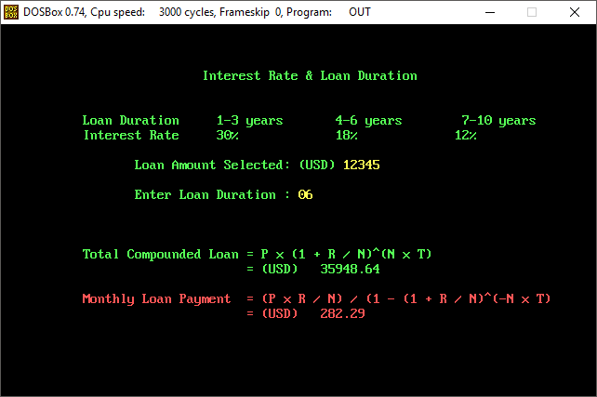

### Load Module Screen 2 - Continue? (Pressed a key)

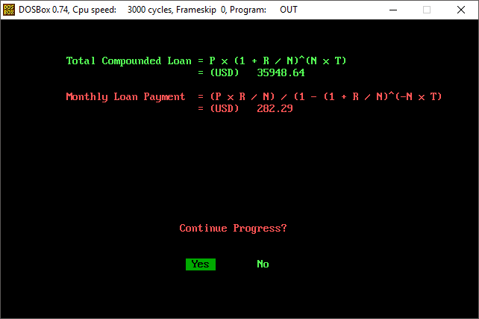

Continue Progress : Yes (Goes back to Loan Module Screen 1)  
Continue Progress : No (Goes back to Main Menu)

### Loan Module Screen 2 - Result (More Samples)

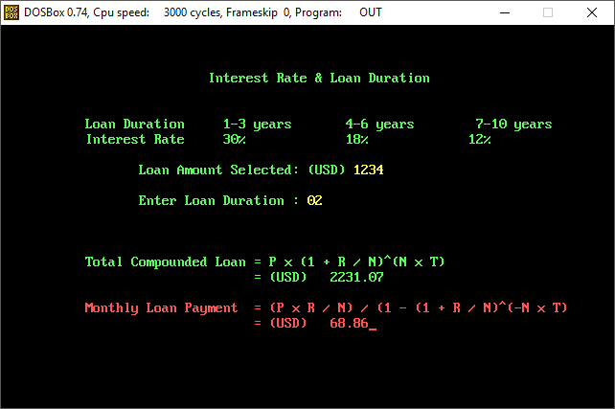

### Load Module Screen 2 - Result (More Samples)

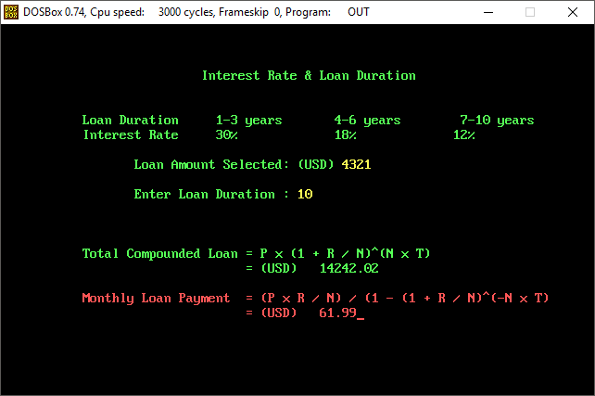

### Loan Module Screen 2 - Result (Min. Result)

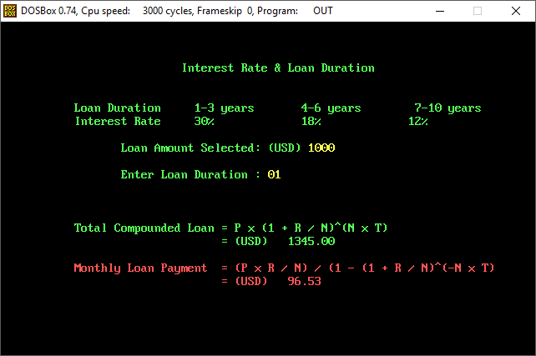

### Loan Module Screen 2 - Result (Max. Result)

### 

### Receipt Module - Main (No Previous Action)

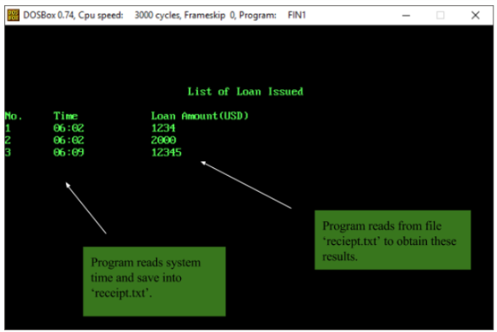  
Sample Data : 12345 USD as Loan Amount

# 

# 

# User Guide

***Wolfe’s Loan Corporation*** also provides a guideline for its employee on how to use the program.

## Software Used

The completion of the program relies on:

* Microsoft Macro Assembler 8.0 (MASM) Package (x86)
* DOSBox 0.74 on Windows 10 v1709
* DOSBox 0.74 on Point Linux 3.2 running Wine 1.6.2-20
* emu8086 v4.0.8 on Windows 10 v1709
* emu8086 v4.0.8 on Point Linux 3.2 running Wine 1.6.2-20

The completion of this document relies on:

* Google Docs
* Google Drive
* Adobe Acrobat DC
* SmartDraw 2013 Enterprise Edition

The requirements on installing and using the software:

* Windows XP and later (only tested on Windows 7 and Windows 10)  
  OR  
  A Linux machine capable of running Wine (only tested on Debian (Jessie) based Point Linux 3.2 running latest Wine version)
* Microsoft Macro Assembler 8.0 (MASM) Package (x86)
* DOSBox 0.74

## 

## 

## Installation

1. Check software requirements.
2. Obtain a copy of the program.
3. Install DOSBox 0.74 .
4. Copy ‘8086’ folder to root directory of any drive (drive C in this example).
5. Copy the [filename].asm and ‘reciept.txt’ files to the ‘8086’ folder.
6. Place
7. Launch DOSBox 0.74 .
8. The following steps will mount the ‘8086’ folder onto the emulator and assemble the source code.   
   On the MS-DOS screen (not the emulator console), type:   
   mount C C:\8086\  
   C:  
   masm [filename].asm;  
   link [filename].obj;
9. The executable (.exe) file should appear in the ‘8086’ folder.
10. To make sure the program runs properly, clear the screen before executing.   
    On the MS-DOS screen, type:  
    cls
11. Execute the program.  
    On the MS-DOS screen, type:  
    [filename].exe

## Login Password

The login password is ‘eeyore’ without quotes.

## Usage Guidelines

To calculate loan:

1. Execute the program as per guided in the ‘Installation’ section.
2. Enter the correct password.
3. Choose the ‘Loan’ module.
4. Enter the amount of loan desired.
5. Enter the number of year on borrowing the loan.
6. Result is displayed.

To display receipt:

1. Execute the program as per guided in the ‘Installation’ section.
2. Enter the correct password.
3. Choose the ‘Receipt’ module.
4. Result is displayed.

# References

1. Lecture Notes on AACS3064 Computer Systems Architecture (2017/2018).
2. documentation for emu8086 - assembler and microprocessor emulator. 2005. Complete 8086 instruction set. [ONLINE] Available at: http://www.emu8086.com/. [Accessed 4 January 2018].
3. Daniel B. Sedory. 2013. A P P E N D I X E S for A Guide to DEBUG ( The Microsoft® DEBUG.EXE Program ). [ONLINE] Available at: http://thestarman.pcministry.com/asm/debug/8086REGs.htm#REGS. [Accessed 4 January 2018].
4. Ralf Brown. 2017. The x86 Interrupt List aka "Ralf Brown's Interrupt List", "RBIL". [ONLINE] Available at: http://www.cs.cmu.edu/afs/cs.cmu.edu/user/ralf/pub/WWW/files.html. [Accessed 4 January 2018].

# Appendices

## The Ladder Diagram (Hand Sketch)

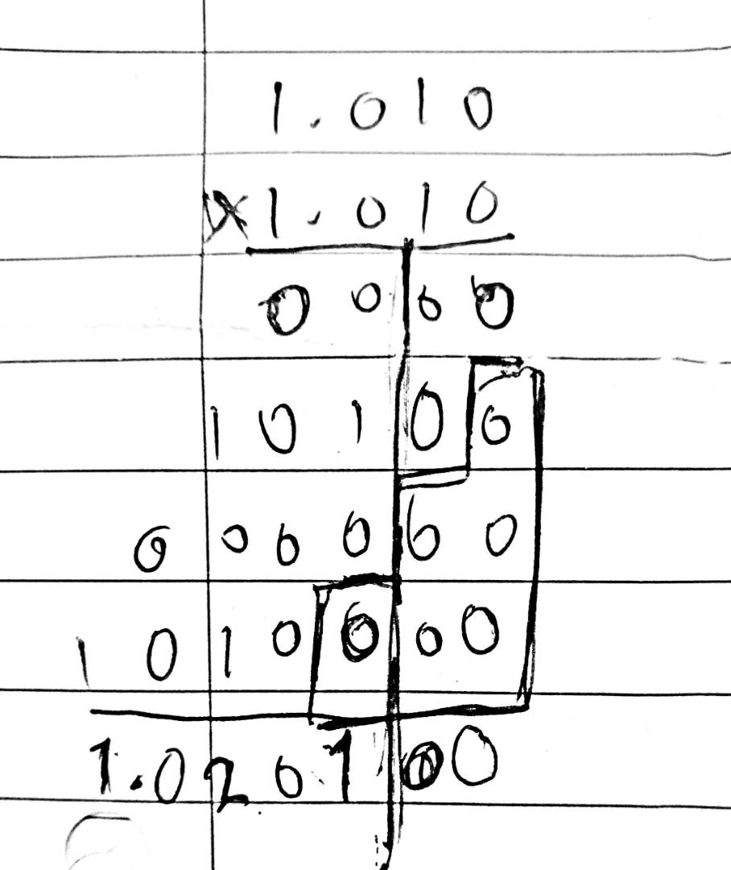  
Used for calculation of a decimal number multiplying with another decimal number.